Mark Krijgsman Delft
Peter Curet October 6, 2008
Index

Index 1
1 Preface 2
2 Project Description 3
3 Hardware 4
3.1 Flock of Birds 4
3.2 OptoTrak 5
4 Software 6
4.1 Python 6
4.2 Integrated Development Environment 6
4.3 WxPython 6
4.4 NumPy 6
4.5 Visualization Toolkit 7
5 Medical Aspects 9
6 References 10

1 Preface

The project we will be working on is provided by staff of the movement laboratory at the LUMC, which is the University Medical Centre in Leiden, in cooperation with the Technical University of Delft (TUD).
During the project we will be working with different technologies. To familiarize ourselves with these technologies, we have conducted research in the relevant areas of computer and medical science. The results of this research will be described in more detail in the following sections.

The work we will be doing is in succession of a previous project, also aimed at improving the Flock of Birds (FoB) application. The Flock of Birds system is a magnetic-transduction technique used for measuring motion, applicable to medical research.
During the previous project, a GUI was made to assist the user in making measurements with the FoB system. A 3D visualization of recorded measurements has also been made possible. In the current situation, the GUI and 3D visualization are not in use yet. Our aim is to improve on the current application by implementing the missing functions essential to the application .

We will continue the following report with a further elaboration of the project assignment we have been given. Subsequently, we will look at the available hardware which we will be working with. In the following section we will look into the software needed to further develop the application. In the last section we will look into the medical portion of the assignment, in order to fully understand the biological aspects in which the project domain is situated.
2 Project Description

During this project, we have different goals, some of which are primary and others which are optional. These optional goals will be evaluated after the primary goals have been completed. The primary goals are listed below.

- Implement a real-time link between hardware and software
- Make the system more generic
- Implement the Centre of Rotation

The most important goal is to implement a link between the hardware and software of the FoB system, making the system ready for practical use. After this has been realized, parts of the existing code will be re-implemented to make the system more generic. This means that sensors can be put on the patient in any order on any body part, allowing the medical specialist to choose which part of the body movements will be measured. In the current application, only shoulder movement measurements are supported. The third goal is to implement functionality that enables the FoB system to make measurements for the shoulder’s Centre of Rotation (COR).
3 Hardware

When measuring shoulder movements, the current hardware used in the application is the Flock of Birds technology. Furthermore, the laboratory has also made the OptoTrak hardware available to us for use with the application. We will look into both tracking system technologies and further elaborate the possibilities of their use.

3.1 Flock of Birds
The Flock of Birds technology that is currently used in the project is a magnetic-transduction technique used for interactive computer graphics applications. The technology can be used for many purposes, in this case the measurement of anatomical parts for medical use.

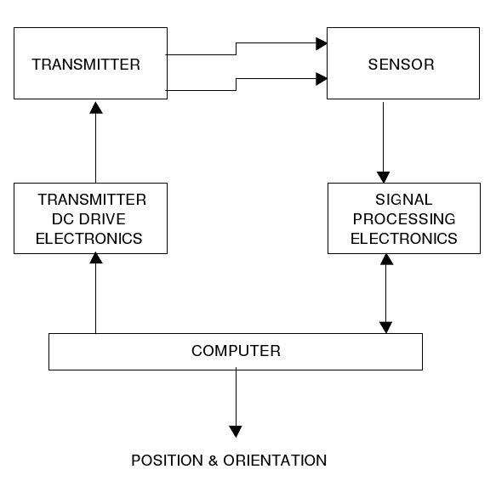
The system consists of the major elements depicted in figure 1. These include a transmitter, transmitter driver circuit, sensor, and signal processing electronics.
Figure 1: A graphical representation of the major elements of the flock of birds^{[1]}

The transmitter is located within a distance of approximately two and a half meters from the sensors. It consists of three individual antennae which are placed in such a way that they share a common centre. In such a way, a multiplicity of direct current magnetic fields are generated, and can be picked up by the sensors.

The position and orientation of one or several receiving antenna sensors can be measured by the flock with respect to the transmitting antenna, which is located at a fixed position. The mentioned receiving antenna sensors can be placed on the user’s head, hand or body. Driving the transmitting antenna is a pulsing direct current (DC) signal.
The receiving sensor antennae measure the transmitted magnetic field pulse. The sensor consists of three axes of antenna that are sensitive to DC magnetic fields. Furthermore, it measures the earth’s magnetic field. This magnetic noise is then removed from the sensor signal and in turn, improves the accuracy of the measurements. The sensor measures the position and orientation of the object to which it is attached, in our case a part of the human body.

Once measurements have been made, the signal output from the sensors is directed to the signal processing electronics. It processes the analogue sensor signals into a digital format that can be read by the computer. Next, an algorithm is used to compute the position and orientation of the sensor with respect to the transmitter and then the information is sent to the user’s computer.
The resulting output contains the positions and orientations of the sensors with respect to the transmitters reference frame. The output of each sensor consists of three words which are the x, y and z positions. The user scales these words to any measuring unit, including inches and meters. The orientation of the transmitting sensor can be output as either nine words as the elements of a 3x3 orientation matrix, the three Euler angles: azimuth, elevation and roll, or the four quaternion elements.

3.2 OptoTrak
Next to improving the software for the FoB system, one of our optional goals is to make the software more generic. This means that functionality could be implemented so that the application can handle both the FoB and OptoTrak hardware effortlessly.
The OptoTrak is a system capable of performing measurements similar to those of the FoB system. However, the way both systems obtain these measurements are quite different.

The OptoTrak makes use of infrared sensors, which are being tracked by several cameras. These cameras are mounted onto a unit called a position sensor, as pictured below in figure 2.

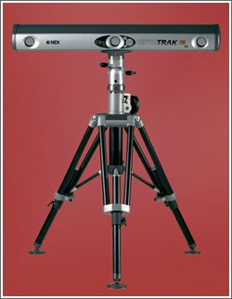

Figure 2: OptoTrak position sensor with standard^{[2]}

The infrared sensors, called markers, are attached to the subject, where three or more markers are needed to determine the 3D orientation of the body^{[3]}. Because the OptoTrak is an optical system, the markers have to be in view of the position sensor at all time. If the position sensor loses track of a marker, it is automatically indentified by the system when they return to view.

In order to further the precision of the movement measurements, the OptoTrak system can be used in combination with the FoB hardware. The results of both systems cancel out each others error, and thus resulting in highly accurate measurements.

4 Software

In order to build on the existing project, it will be important to understand the concepts of the software which will be used. In the following sections we will look into several software tools needed in the development process.

4.1 Python
Python is a programming language that mainly emphasizes four concepts.^{[4]}

- Quality:
Python strives to keep a clear syntax, so that any code written in Python will be readable and easy to maintain. Python also focuses on easy extensibility, which is provided by a relatively small language core and an extensive standard library.
- Productivity:
Because the interpreter handles things such as type declarations, memory management and build procedures, (initial) development is easy so that productivity can be increased. The aforementioned point of clear syntax also increases productivity.
Furthermore, Python supports paradigms such as object oriented programming so that programmers can choose between several ways of designing their programs.
- Portability:
It is possible to run most Python programs under different operating systems, including Microsoft Windows, Macintosh OS X and Linux.
- Integration:
One of Python’s uses is that of a “glue language”. This means that Python can be used to connect several components made in different programming languages. For example, with Python it is possible to call C and C++ libraries, talk to Java classes and vice versa.

4.2 Integrated Development Environment
The Integrated Development Environment (IDE) we will be using to edit and compile our code with is Eclipse. An extension for Eclipse exists, called Pydev, which provides a syntax highlighter, code completion and syntax analysis. ^{[5]}

4.3 WxPython
One of the toolkits being used during the project is wxPython. This toolkit is used for the construction of the GUI and is implemented as a Python extension module that wraps around the GUI library wxWidgets. wxPython is open source and cross platform, currently supporting the 32-bit version of Windows, Macintosh OS X and most Unix systems^{[6]}.

4.4 NumPy
NumPy is a package for scientific computing with Python, providing support for managing large data sets in arrays, rather than using the standard data structures such as tuples and lists. With NumPy, much less time and space is used to run programs that manipulate large sets of data ^{[7]}. Because the FoB data consists of matrices, NumPy is essential to ensure that our programs runs at reasonable speed and to provide functions needed to manipulate the arrays of data.

4.5 Visualization Toolkit
For the visualization of the recorded motion in the FoB application, the Visualization Toolkit (VTK) is used. It is an open source, object-oriented toolkit for the visualization of 3D data^{[2]}. While it is implemented in C++, the toolkit can be used on other languages as well, including Python, which we will be using.
VTK has been created with a couple of common conventions to assure the consistency of the code. One example is the method names which have all been fully spelled out. The result makes it much easier for developers to remember methods. Furthermore, all member variables are either private or protected and can only be accessed from other classes through Set() and Get() methods.
Streamlines, ISO-contouring, glyphing, clipping, and cutting are part of the wide range of visualization techniques available through the toolkit. The API of VTK includes objects such as lights, cameras and actors, which can all be displayed within a render window. This window creates a viewport for each of its renderers and in turn gives them control to set up a camera and lights. Following this, each actor is rendered. All actors have properties and each are independent of each other.
Each object in the API has a broad range of functionalities. Examples are the parameters of lights which can be adjusted to have colour, and the possibility to adjust the parameters so that infinite light or spotlights can be simulated. Actor objects have a matrix transformation to indicate its current positions and scale in the world coordinates. Furthermore, it has properties such as ambient, diffuse, and specular colours, wire-frame versus surface rendering, and front- or back-face culling.
This graphics model contains the essential properties of a standard 3D graphics system. It is based on movie-making, and graphical user interface windows applications. Figure 3 gives a basic explanation of the VTK graphic model and its objects^{[8]}.

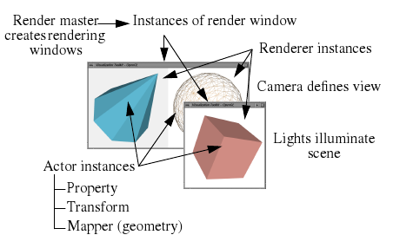
Figure 3: VTK graphic model^{[8]}
The following are the basic objects in the model^{[9]}, each with a description of its functionalities.

1. Render Master - coordinates device-independent methods and creates rendering windows.
2. Render Window - manages a window on the display device. One or more renderers draw into a render window to generate a scene (i.e., ﬁnal image).
3. Renderer - coordinates the rendering of lights, cameras, and actors.
4. Light - illuminates the actors in a scene.
5. Camera - defines the view position, focal point, and other camera characteristics.
6. Actor - an object drawn by a renderer in the scene. Actors are defined in terms of mapper, property, and transform objects.
7. Property - represents the rendered attributes of an actor including object colour, lighting (e.g., specular, ambient, diffuse), texture map, drawing style (e.g., wireframe or shaded); and shading style.
8. Mapper - represents the geometric definition of an actor and maps the object through a lookup table. More than one actor may refer to the same mapper.
9. Transform - an object that consists of a 4x4 transformation matrix and methods to modify the matrix. It specifies the position and orientation of actors, cameras, and lights.

In the FoB application, VTK will mainly be used for the visualization of the skeletal model. The model will move according to real time or recorded motion. Each bone is loaded into the application separately and added to a mapper. Then, actors referring each to a mapped bone is set to the right position. During the visualization, the angle and position of each actor and thus bone, will be updated according to the real time or recorded data of the corresponding sensors.
5 Medical Aspects

The current application we will be working on supports motion tracking for shoulder movements. Although it might be possible to track other parts of the body with the system, we will currently be focusing on the shoulder and its anatomy. To familiarize ourselves with the terms we have looked into the human anatomy briefly. Figure 4 displays the skeletal structure of a human body.
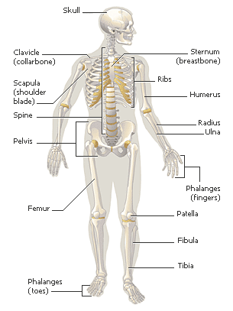
Figure 4: Human skeletal structure^{[10]}

The human skeleton is a strong, flexible framework of 206 bones that supports the body and protects internal organs. The bones of the skeleton connect at joints to permit a wide range of body movements ^{[10]}.

Through the tracking of this wide range of movements, joint and skeletal problems can be diagnosed and results of physical therapy can be detected. The three dimensional tracking application we will be working on can be a helpful tool for medical specialists. Studies have shown^{[11]} similar tracking methods have proven successful in the diagnosis of medical problems such as frozen shoulders, a medical condition which causes pain and distinct movement patterns for the patient. Moreover, the system used in the study was also able to detect the results of clinical improvement.
6 References

[1] Flock of Birds - Six Degrees of Freedom Measurement Device - Technical Description of DC Magnetic Trackers
Ascension Technology Corporation, Burlington, VT
http://www.5dt.com/downloads/3rdparty/fobtechnicalspec.pdf
Retrieved on 06-10-08
[2] OptotrakProSeries Image
http://www.central-scanning.co.uk/images/OptotrakProSeries.jpg
Retrieved on 03-10-08
[3] The Optotrak System
http://p3.smpp.northwestern.edu/BMEC66/stroke/Optotrak.htm
Retrieved on 03-10-08
[4] Programming Python: Object-Oriented Scripting (2001)
Mark Lutz
http://books.google.nl/books?id=37_AJDlEytEC&printsec=frontcover&hl=en
Retrieved on 28-09-08
[5] Pydev
http://pydev.sourceforge.net/
Retrieved on 06-10-08
[6] What is wxPython
http://wxpython.org/what.php
Retrieved on 28-09-08
[7] Numerical Python (2001)
David Ascher, Paul F. Dubois, Konrad Hinsen, Jim Hugunin, Travis Oliphant
http://www-int.stsci.edu/~jinger/ad5/web/ad4/irafx/docs/numpy.pdf
Retrieved on 28-09-08
[8] What Is VTK?
http://www.vtk.org/what-is-vtk.php
Retrieved on 06-10-08
[8] The Design and Implementation Of An Object-Oriented Toolkit For 3D Graphics And Visualization
William J. Schroeder, Kenneth M. Martin, William E. Lorensen, GE Corporate Research & Development
http://www.vtk.org/pdf/dioot.pdf
Retrieved on 28-09-08
[10] MSN Encarta: Human Skeleton
http://encarta.msn.com/media_701508645_761552814_-1_1/Human_Skeleton.html
Retrieved on 26-09-08
[11] Measurement of three dimensional shoulder movement patterns with an electromagnetic tracking device in patients with a frozen shoulder (2002)
H M Vermeulen, M Stokdijk, P H C Eilers, C G M Meskers, P M Rozing, T P M Vliet Vlieland
http://www.pubmedcentral.nih.gov/picrender.fcgi?artid=1753981&blobtype=pdf
Retrieved on 25-09-08

